October 1, 2012
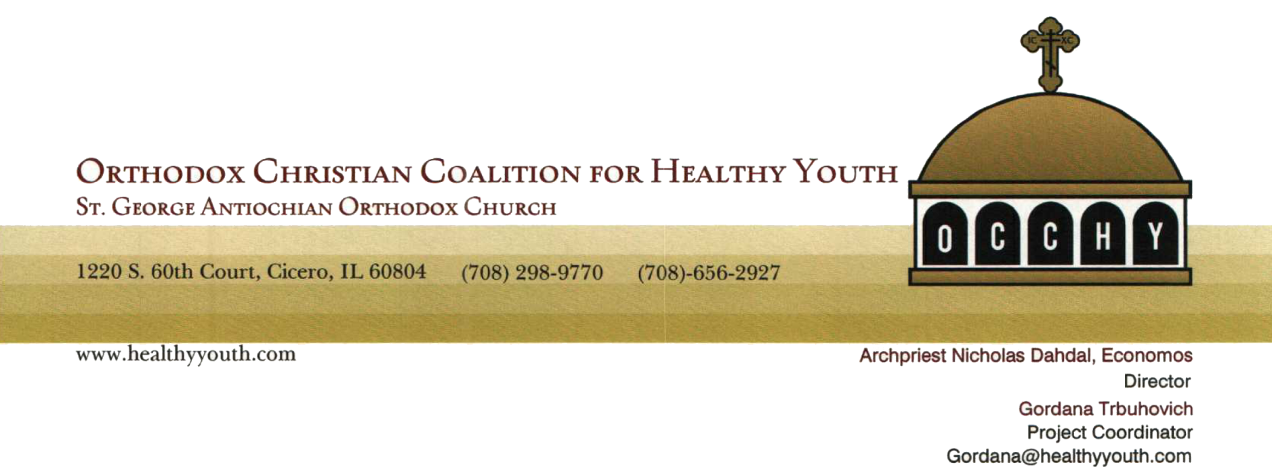
FOR IMMEDIATE RELEASE
Chicago area Pan-Orthodox program aimed at substance use prevention among youth

CICERO, IL -- The Orthodox Christian Coalition for Healthy Youth [OCCHY], a national alliance offering communities an opportunity to heighten awareness of how to combat substance use/abuse, prevent bullying, encourage all sexual abstinence outside of marriage, and encourage respect for the sanctity of the human body, recently established headquarters in Cicero, IL.

Heading Greater Chicago Area OCCHY operations is Project Coordinator, Gordana Trbuhovich, who is well known among Serbian, as well as the metropolitan area’s Pan Orthodox, communities. Gordana brings many years of organizational experience to the coalition's efforts.

Founded by the Department of Youth Ministries of the Antiochian Orthodox Christian Archdiocese of North America, in conjunction with Community Anti-Drug Coalitions of America, OCCHY was awarded a five-year Drug Free Community matching grant of $125,000.00 per year, according to Archpriest Nicholas Dahdal, OCCHY Director. This is the first faith-based Orthodox Christian organization to be awarded the grant, primarily due to the vast number (near 80) of Orthodox Christian parishes located in the greater Chicago area.
"Your respective bishops have all been informed of OCCHY's new beginning, and we are thankful for their acknowledgement and blessings to go forth and to address this challenge together in the greater Chicago Orthodox Christian community," Father Nicholas wrote in a letter dated August 10, 2012 addressed to all Chicago-area parishes.
Visit OCCHY's web site at www.healthyyouth.com. For additional information please contact Ms. Trbuhovich at (708)298-9770 or Gordana@healthyyouth.com .
###

